**Project Topic: Cab Booking System**

**Project Scope:**

Designed and implemented an SQL database for a cab booking platform to model real-world ride-hailing operations. The system included structured tables for customers, drivers, trips, and payments. Realistic sample data was inserted, and advanced SQL queries were written to analyze customer behavior, evaluate driver performance, and identify trip trends, enabling data-driven insights into operational efficiency and user engagement.

**1. Database Design (DDL - Data Definition Language):**

1. **ER Diagram**

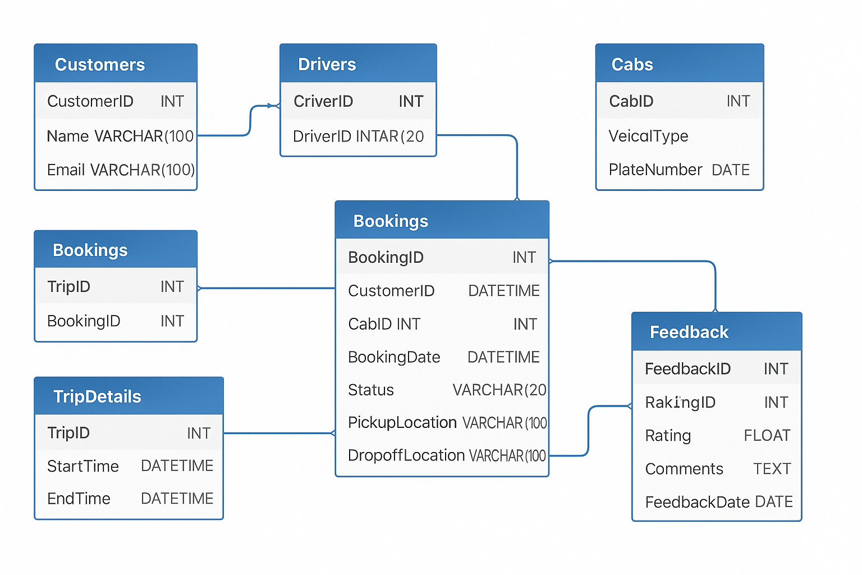

1. **User Case Diagram**

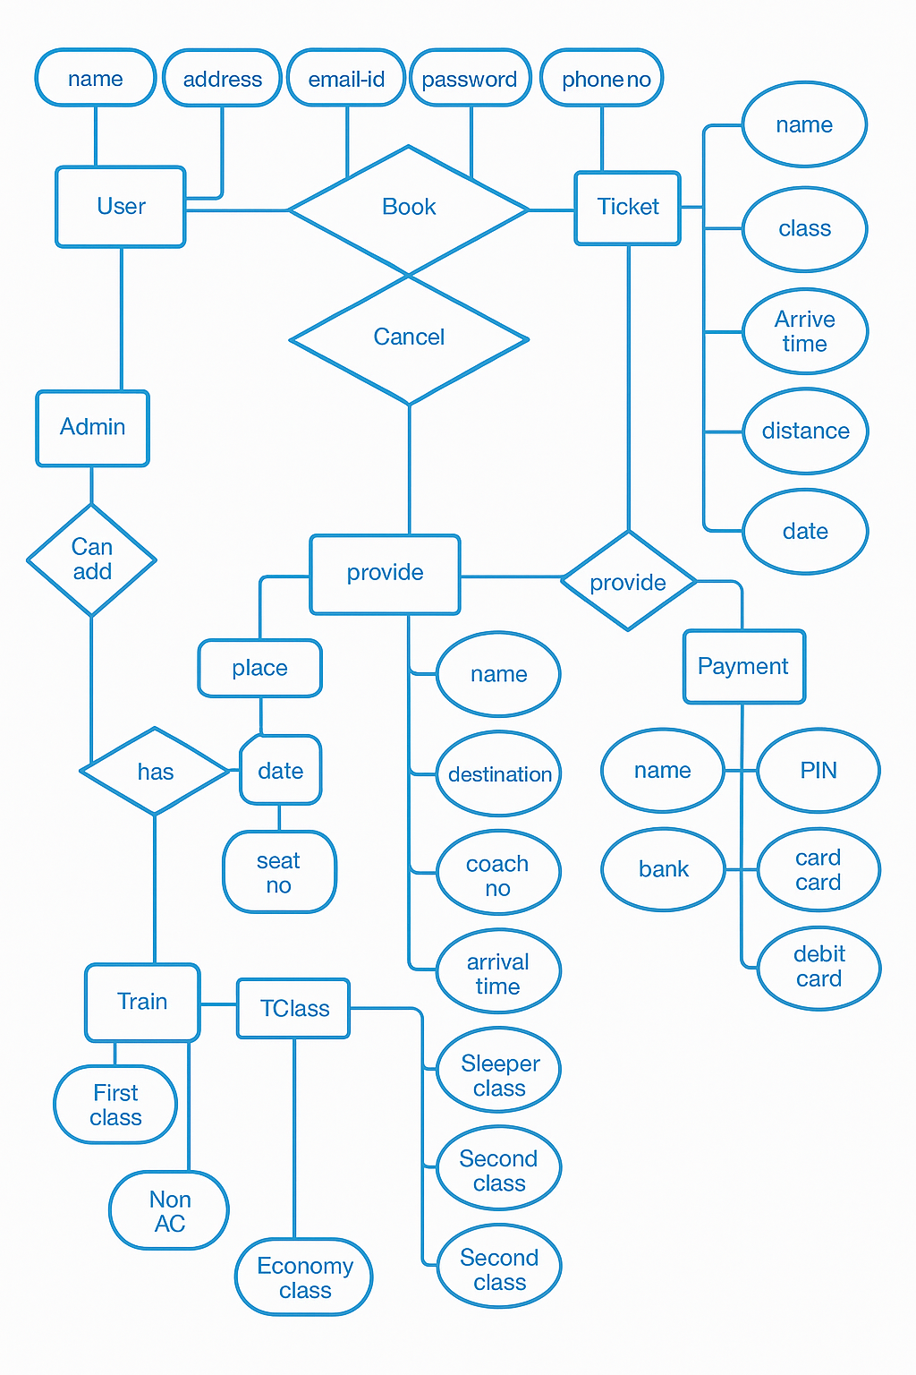

1. **Tables**
2. **Customers**

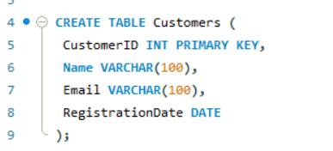

1. **Drivers**

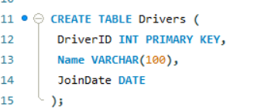

1. **Cabs**

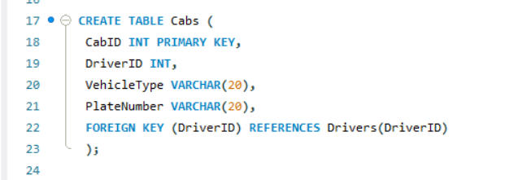

1. **Bookings**

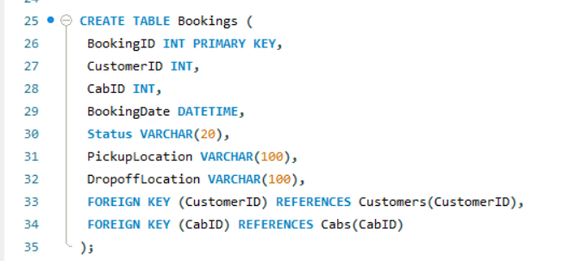

1. **Trip Details**

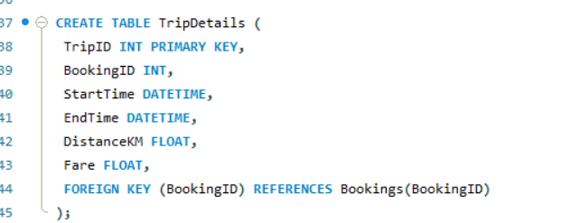

1. **Feedback**

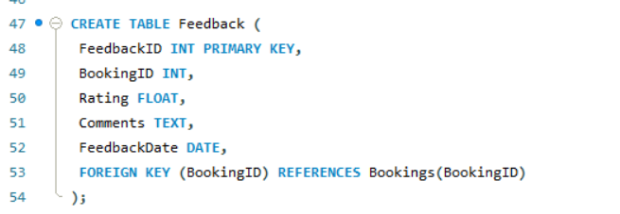

**2. Populating Data (DML - Data Manipulation Language):**

1. **Customers**

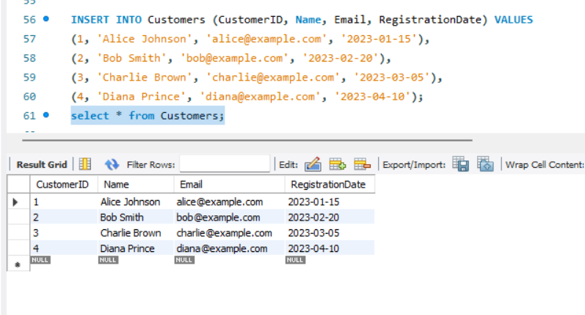

1. **Drivers**

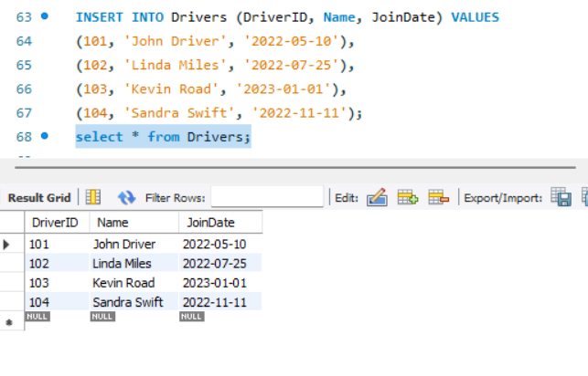

1. **Cabs**

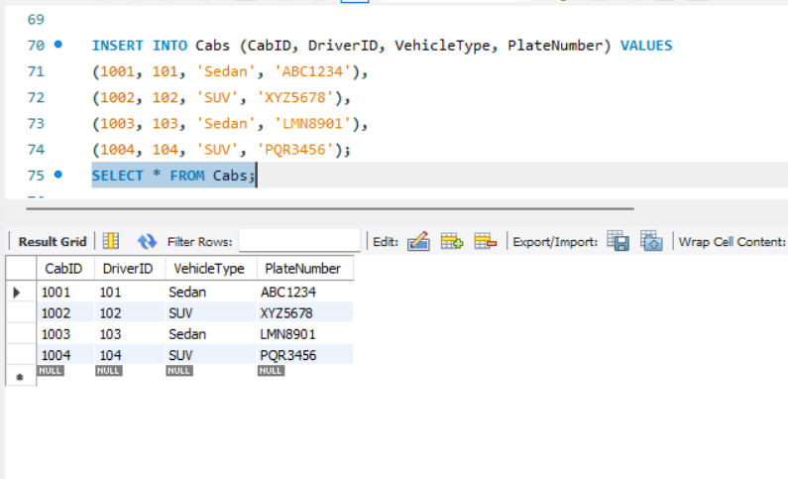

1. **Bookings**

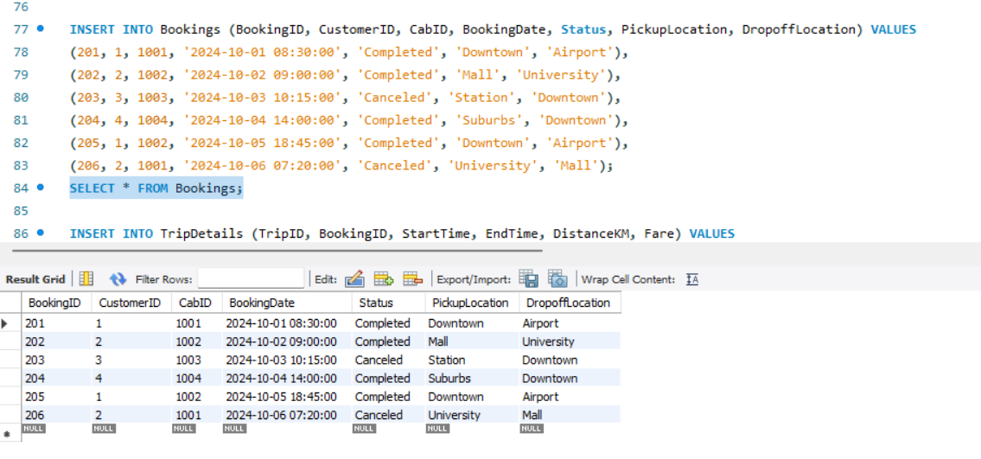

1. **Trip Details**

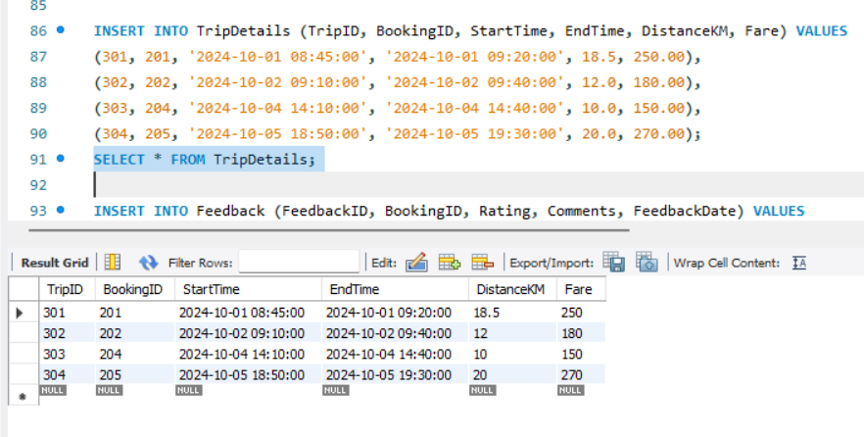

1. **Feedback**

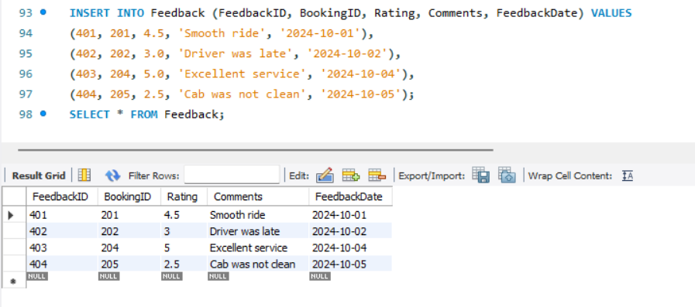

**3. Querying Data (DQL - Data Query Language):**

1. **Show bookings with status 'Completed’**

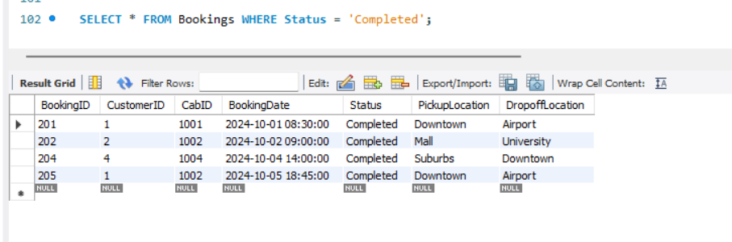

1. **Get all cabs of type 'Sedan'**

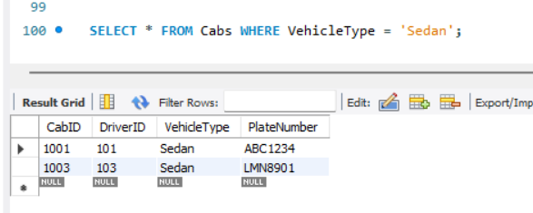

1. **Get the highest fare**

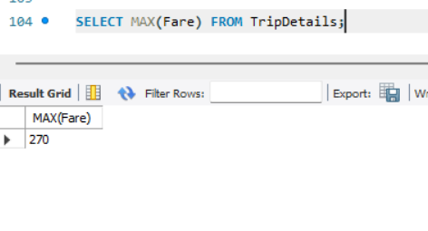

1. **Count bookings per status**

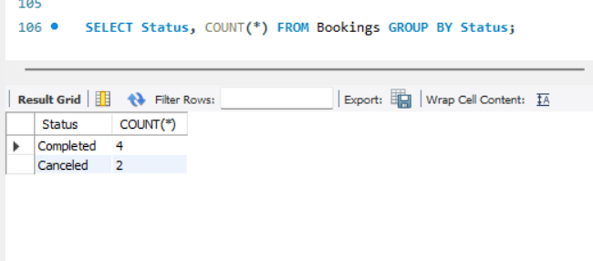

1. **Show customers whose name starts with 'A'**

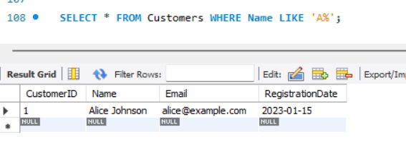

**4. Advanced Queries and Subqueries:**

1. **Bookings with fare above average**

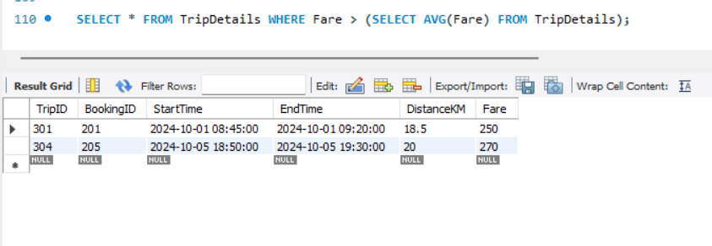

1. **Cab with most bookings**

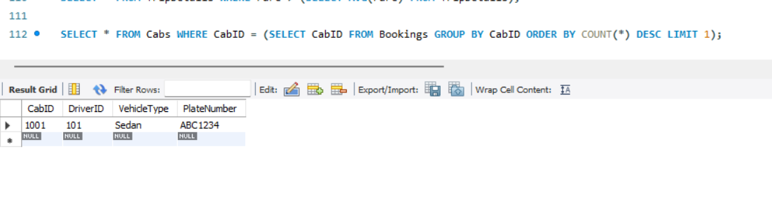

1. **Trip with longest distance**

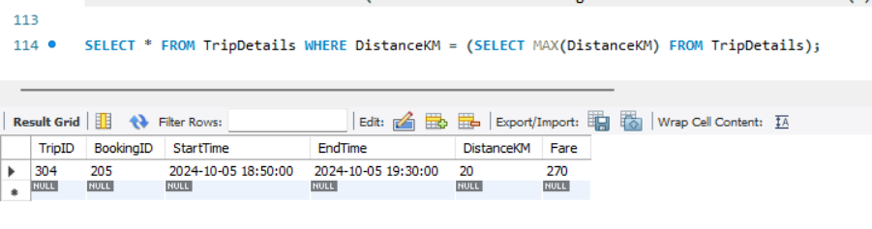

1. **Customers who never gave feedback**

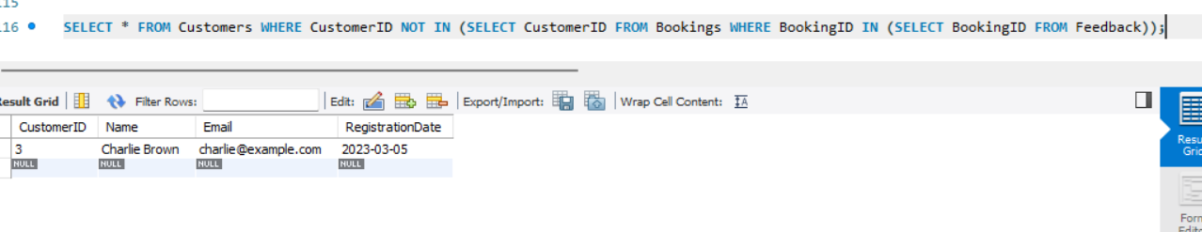

1. **Find the names of customers who gave a rating of less than 3**

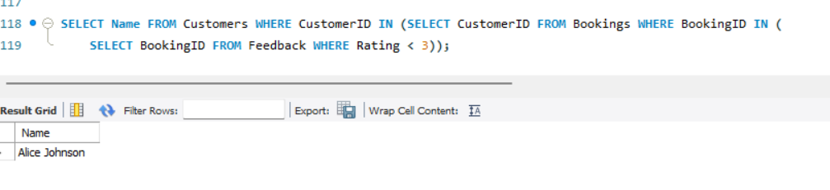

**5. Using Joins:**

1. **Customer details with their bookings**

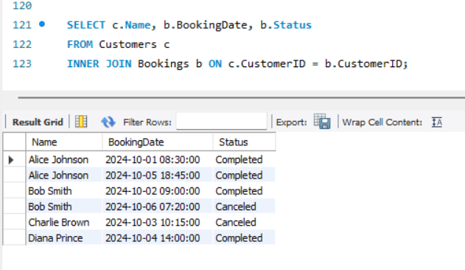

1. **All bookings and customer info**

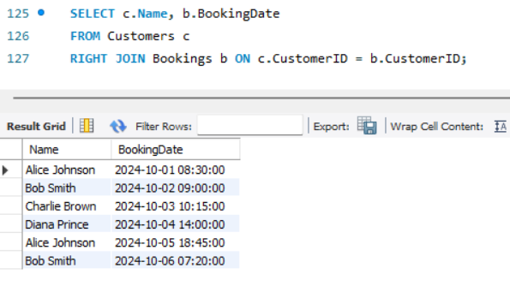

1. **Generate a grid of feedback and rating values**

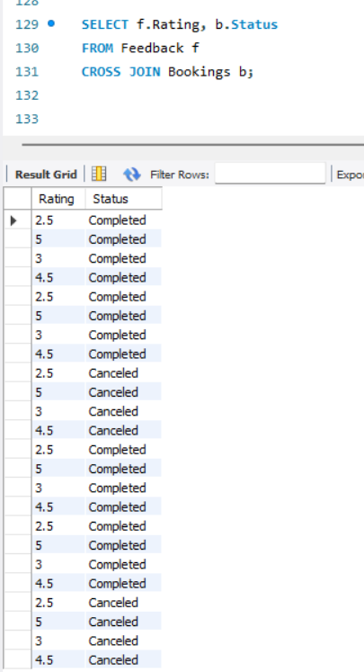

1. **Pair bookings with the same cab but different customers**

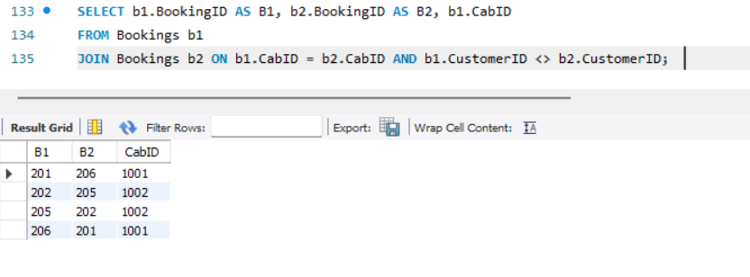

1. **Drivers and cabs (include all, even if not matched)**

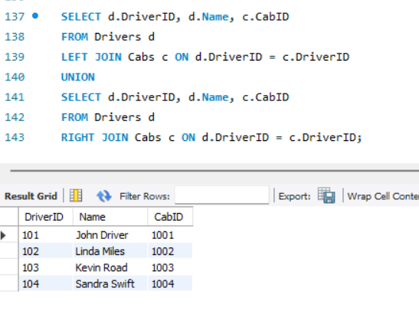

**6. Creating Views:**

1. **View_CustomerBookings-** Shows customers with their booking details

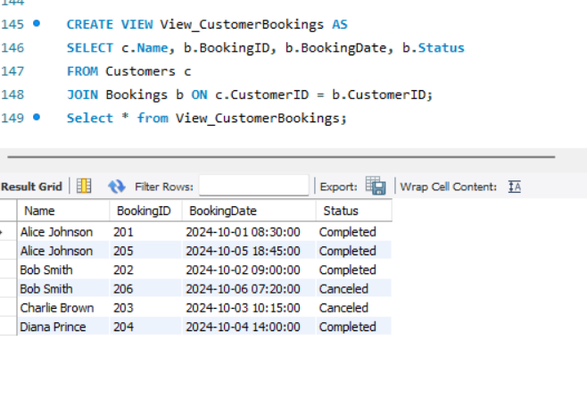

1. **View_TripSummary-** Summarizes trip distance and fare by trip

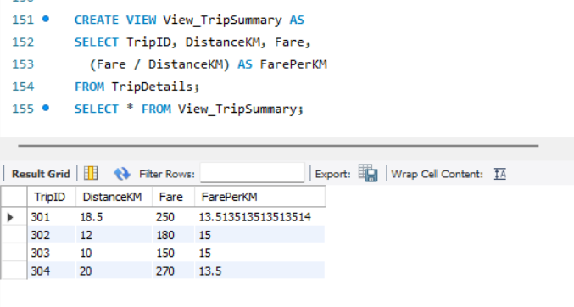

1. **View_CabUtilization-** Total trips and earnings per cab

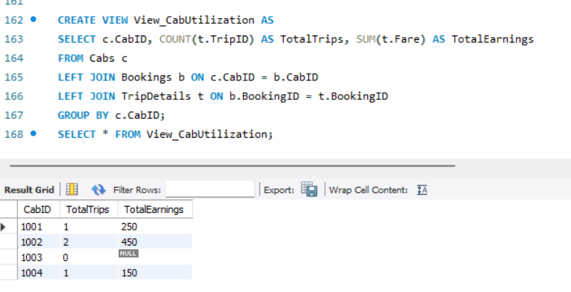

1. **View_AverageFarePerKM-** Calculate average fare per km

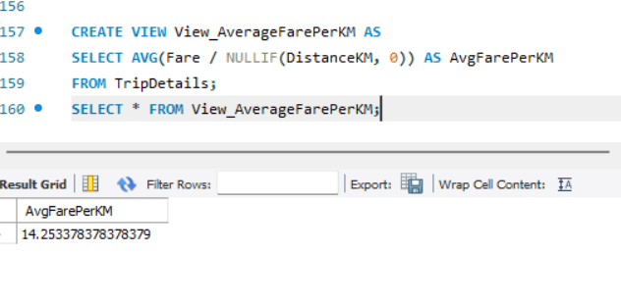

**Insights Gained-**

1. **Customer Behaviour:**

* Frequent patterns such as customers who tend to complete bookings or those whose names follow specific trends (e.g., starting with 'A').
* Identification of customers who gave poor feedback (ratings below 3) or never provided any feedback, helping in targeted service improvement.

1. **Driver and Cab Utilization:**

* Detection of the most utilized cabs and drivers through query analysis (e.g., cab with the most bookings).
* Evaluation of drivers regardless of current assignments using outer joins to spot inactive or underutilized resources.

1. **Trip and Fare Trends:**

* Identification of trips with the longest distances and fares above average, helping understand high-revenue operations.
* View-based summaries like TripSummary and AverageFarePerKM provided key metrics for operational efficiency.

1. **Operational Efficiency:**

* Bookings grouped by status revealed overall system throughput.
* Pairing bookings by cabs and customers offered insight into shared usage patterns and cab reusability.

**Conclusion-** The Cab Booking System project effectively modeled a real-world ride-hailing scenario using a structured SQL-based approach. Through comprehensive data insertion, querying, and view creation, the system enabled valuable insights into customer preferences, driver performance, and cab utilization. This data-driven design not only supports efficient operations but also lays the foundation for future features like predictive demand or dynamic pricing.